***This automation will push any Facebook posts you make to your Google Business Profile.***

For reference, I use the abbreviation GMB for “Google My Business” which is what it was called before it’s current name Google Business Profile.  
  
Note that it doesn’t work with Reels, and there aren’t any schedulers to my knowledge that let you schedule videos/reels to GMB. If you want to include videos on your GMB, you’ll have to post them directly from within Google.  
  
However, if you made a “video post” (so a video, but not a Reel), the automation will send a “screenshot” from the video to GMB. You can’t control this screenshot lol, so it can be pretty random. I don’t even worry about it and just let it ride!!! For example: only blue sky from this reel:

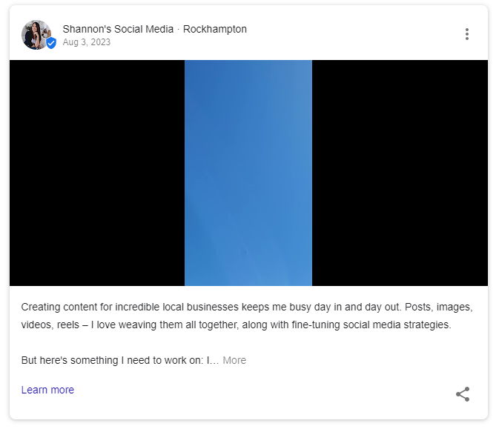

You only need a free Zapier account to set up this automation, and its one I use with my clients and share with 1:1 training and coaching services. It should only take a few minutes for you to set up. ([www.zapier.com](http://www.zapier.com))

There are 2 steps to this, and I have included screenshots for you. Ready?

**Step 1: Create a new zap**

See screenshots below

1. For Trigger, select *Facebook Pages* (assuming you have a FB page set up for your business)
2. Event is *New Post By You* then *Continue*
3. Account is your Facebook account (you’ll need to attach/link it if you haven’t already)
4. Then select the Facebook Page for your business
5. Then *Test Trigger*. Zapier should find a recent post from your Facebook page and you can select *Continue with selected record* to continue setting up and testing the zap.

**Step 2: Action**

Screenshots are below.

1. Select *Google My Business* as the Action app
2. Event is *Create Post*, and then click *Continue*
3. Select your *Account* – this should be your Google account linked to your Google Business Profile (you’ll need to attach/link it if you haven’t already)
4. Under the *Action* menu, choose the *Location* (which is your business)
5. For Summary, select *1. Message:*
6. Topic Type is *Standard*
7. Action Button Type: I use *Learn More\**
8. Action Button URL: I put my website here so if they click Learn More*, it takes them to my website (but you could also put your Facebook or Instagram links here)
9. Photo Source URL is *1. Full Picture*

Now you should be able to test it, and all going well, it is ready to set up and PUBLISH. (Unless you get an Error Message (but hopefully not!). If this is the case, we can try and troubleshoot it together.)